Capturing Sediment on the Go, Enabling Clean Water to Flow!
For as long as we all can remember, what is least expensive & approved is what is going to be used. Bids are submitted per project. So, one and done solutions seem to be the mainstay. When installed properly, inspected, cleaned, and replaced- these solutions perform up to “approval”.
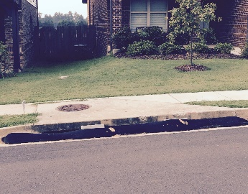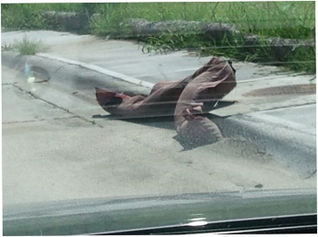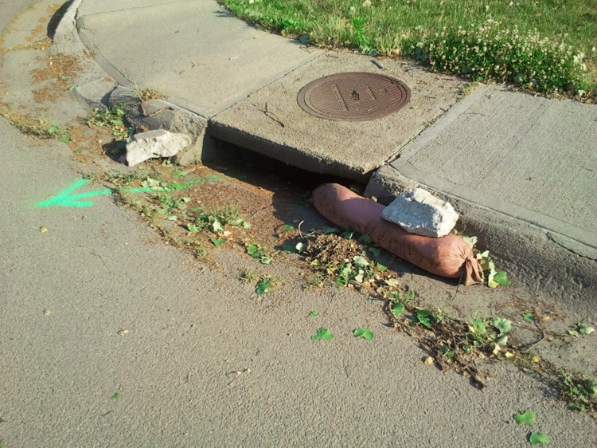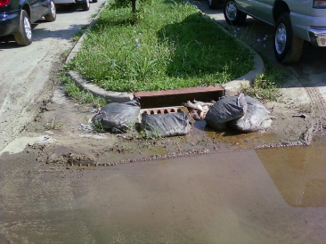
These solutions above are approved. Upon inspection of site, this contractor would have a set time period to correct. What about: when it isn’t “caught”!!
As society sees the need to keep our water clean, there are solutions which are addressing the problems that have existed with some of the approved products or systems.
Current Solutions Require Sacrifices
- Impediment to traffic: Reducing Traffic Lane Size or Lane Closures. When traffic drives over, or through temporary solutions, you are reducing their effectiveness.
- Flooding: Lower flow rates, current systems clogging, No Overflows built in, and lack of maintenance are a few of the reasons we need to look at current solutions that are available.
- Current Regulations are leaning towards solutions which must be inspected in a timely manner & after each large storm event. One and done solutions become costly to all when they must be replaced, instead of reused.
- Inconsistent use, manufacturing, handling, installation, etc. can make it nearly impossible to consistent levels of sediment control. If it rains too much, if it is driven on, if it moves, etc. result in untreated entry of stormwater into the Underground Infrastructure systems. Sediment, trash, debris & more entering our systems resulting in more costs in future.
- Contractors are paid to install controls. Not to remove. Numerous current Inlet Protection Practices remain at site, and become debris themselves eventually.
Advancements in Inlet Protection are addressing many of these issues.
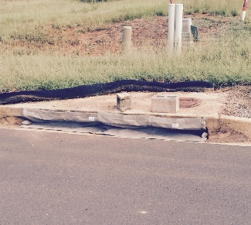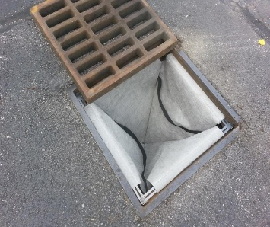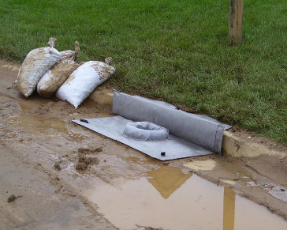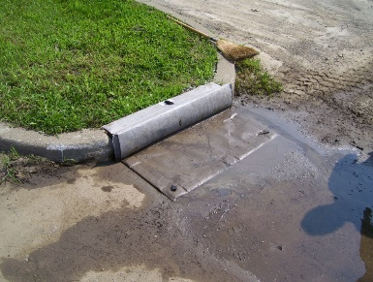
EZ-ClipGuard EZ-Catch EZ-Flo w/ OverFlo EZ-Flo
- Traffic Friendly: These solutions are working to keep traffic moving without impediments. Safety, costs, and stress are all effected positively. Whether Recessed Curb Inlet, Under Grate, or Above Grate Inlet Protection Solutions the overall effects on traffic is positive.
- Increased flow rates and overflows: Address pooling of water. Industry Flow Rates have increased with advancements in technology. Combining overflow with advanced flow rates and Sediment Control will drastically reduce the chance the pooling or flooding of water resulting from solutions which are relying solely on proper maintenance and rotation (or Replacement).
- Maintenance Friendly: Advancements in Inlet Protection are making installation, cleaning, rotating or replacement of products much easier and less time consuming. Promoting proper inspection and replacement.
- Reusable Inlet Protection reduces project costs now and in future.
- Sediment, trash, & debris entry into underground infrastructure reduced dramatically. Consistent Inlet Protection with measurable reductions in the NTU Levels makes the practices of sediment control much more consistent.
- Solutions that can stay for post construction use. These Current Practices promote use during construction & Post Construction. Again, striving more towards achieving cleaner waters.
As Contractors, Agencies, StormWater Professionals, and the public see the increased need and desire for our water to be cleaned, reused, and preserved: it is positive to see advancements in systems that can facilitate these wanted results. Now, we need to address the standards set for approved systems. Cheapest solutions are not the least expensive- and rarely achieve the best results.
Municipalities, Universities, Military, Facilities, Developments.
How much do we spend on underground infrastructure systems? A lot. Aside from building, the maintenance and repair & the annual cleaning out of systems, starts adding up.

Further Benefits of Construction and Post Construction Use.
- Cleaner Stormwater Entering our Bodies of Water
- Job Creation
- Drastic reduction of the debris, trash, sediment, etc. from entering our Underground Infrastructure Systems.
- Streamlined Inspection Process for BMP’s.
- Environmental advancements made by and for your community.
EZ-Catch, EZ-Flo, EZ-GlipGuard I Future Inlet Protection Advancements are the first step.
Reducing the dollars spent on repair, maintenance. & cleanings dramatically.
- 2 Units of Inlet Protection per Outlet so solutions can be rotated and cleaned when needed.
- Labor to rotate these every 2-3 months (Back for cleaning, and back wash)
- Labor to inspect following large rain events
So, let's step up. Which municipality, military branch, company would like to be involved in showing the rest of the world how following what you do will result in greatness for all while. . . . . . . . . . . . . . . . .

Combining use During Construction with Proper Inlet Protection with use in Post Construction areas provides multiple benefits. The largest benefit is Clean Water.
S0, can’t we all see the benefits of Capturing Sediment on the Go, Enabling Clean Water to Flow.

Corydon Coppola, CPESC
President of Flo-Water

